Paul Parker

CS373

Lab 2: Web Tracking

3.1 Task 1

First visit to [www.tlabelgg.com](http://www.tlabelgg.com) shows me:

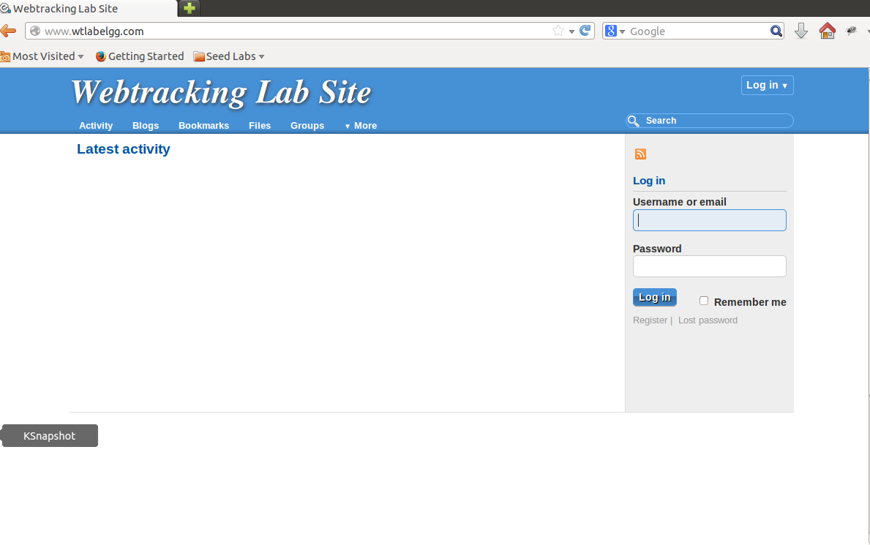

Mostly blank with a log in ui on the right.

After visiting a product site there is now an image of the product I viewed at the bottom of the Elgg site.

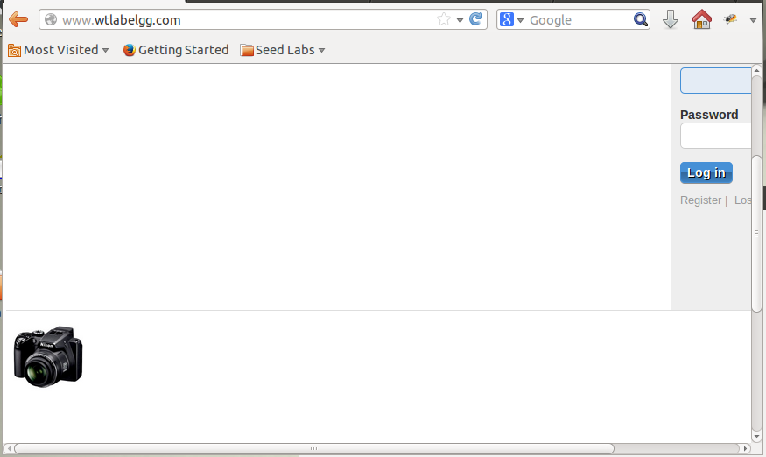

Task 2

Visiting the camera store site and clicking on a product shows one request to a different host with a set cookie header:

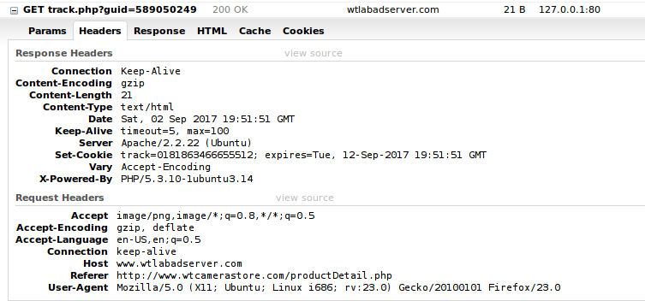

This request was triggered by an img tag with an unusual source:



The Cookies being set for the product website are the same cookies being read by the ad server website

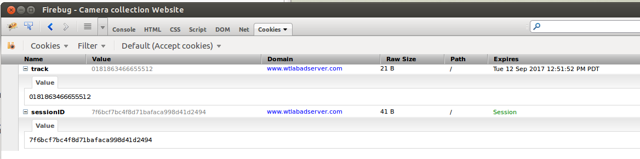

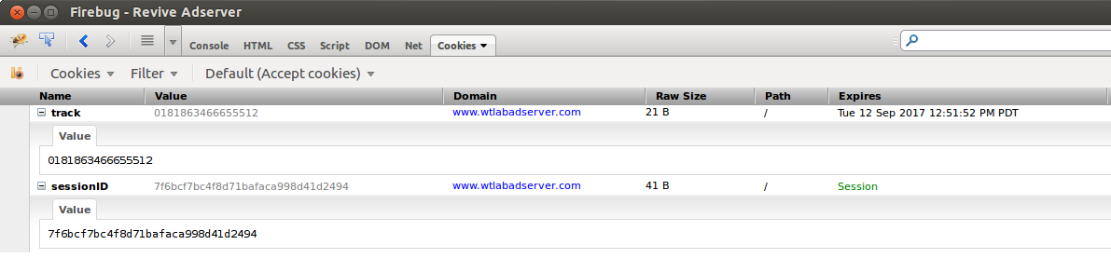

These are third-party cookies because they are set by a domain other than the one for the website we are looking at. In this case the cookies were set by requests from the camera store website to the ad server website for the ad server domain.

Task 3:

I imagine each product is tracked by a guid. The embedded images that make requests to the ad server have the product guid as part of the query string. The initial one sets a session id cookie. That session id cookie is used to track a browsing session across multiple sites. Each site reads the session id and posts it a long with the product guid to the ad site which updates the product database.

Task 4

The Elgg site reads the session id from the cookie and uses it as part of the request to the ad server for ad information:

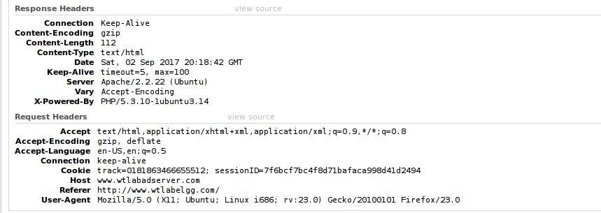

The ad server then responds with ad information about products that are related to the session id in the database.

Task 5:

Similar to the start of task 1, visiting the Elgg site shows no ad at the bottom. Once I visit a product page and refresh the Elgg site I see an add at the bottom for the product I visited. Closing and re-opening the private browser the Elgg no longer shows an ad.

You can see that the cookies on the first visit of a private window to the Elgg site are different that after visiting the products.

First visit in a private browsing session:

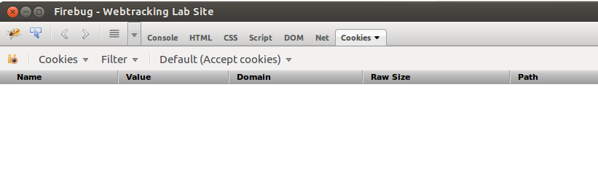

After viewing product:

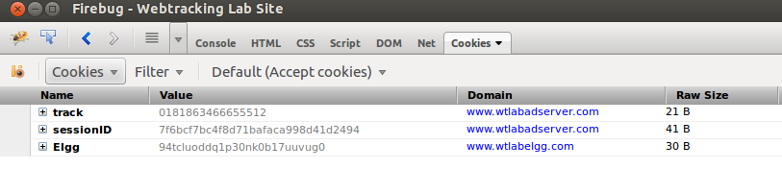

Task 6

Dictionary.com

Request that set a cookie:

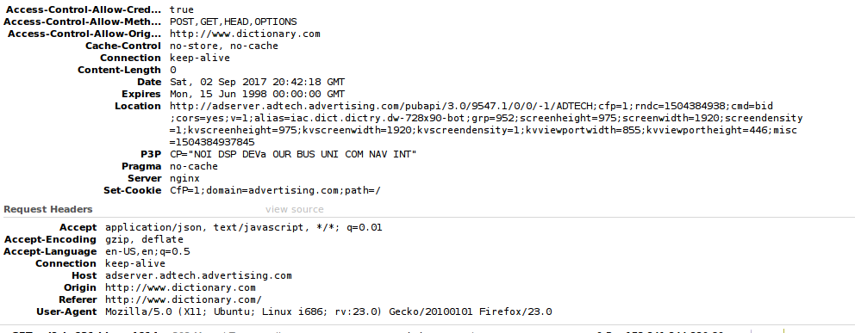

Amazon.com request that used cookie set by other website:

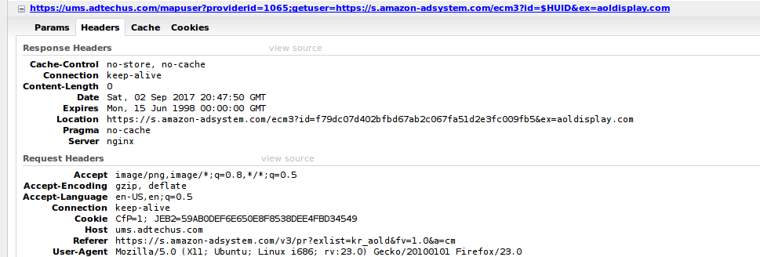

The cookie is CfP=1 on the header same cookie set from previous image.

Careerbuild.com

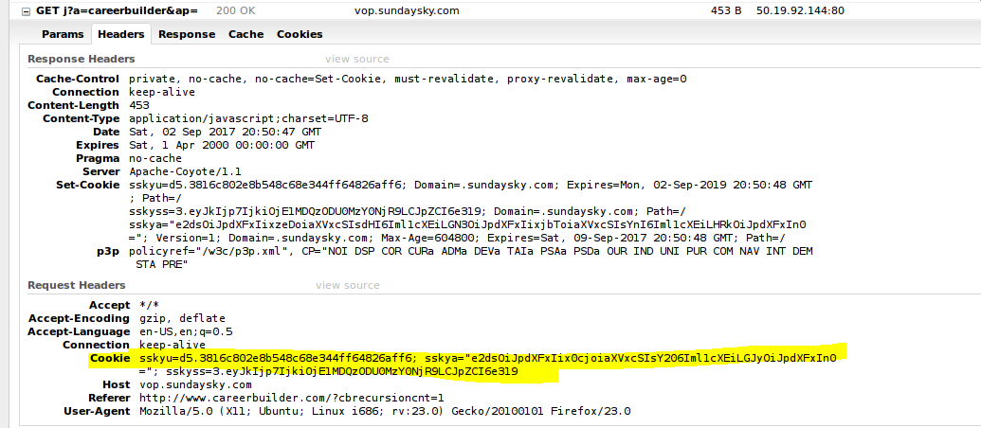

Task 7

With cookies that were disabled here is a request that tried to set a third party cookie:

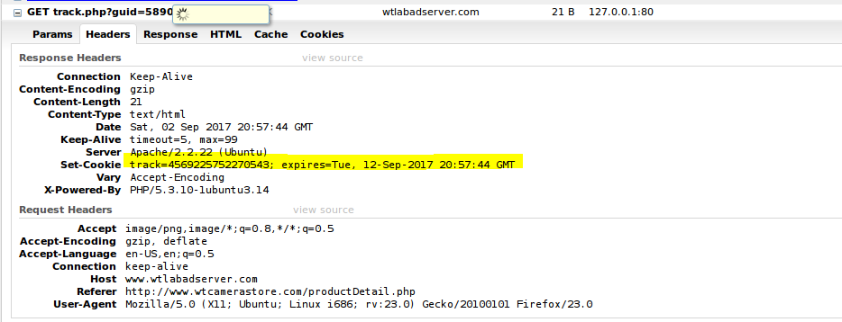

Visiting the Elgg website this a request to the adserver:

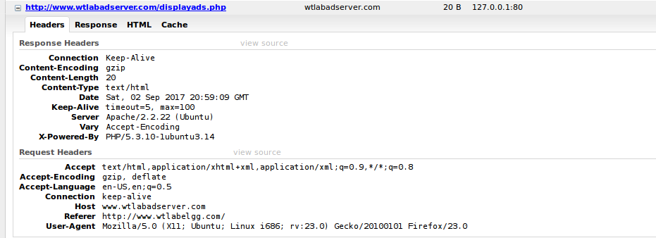

In this case there is no ad at the bottom of the Elgg site.

Lab Summary:

This lab wasn’t too difficult for me to understand or execute. I am a front end web developer and know my way around browsers cookies and reading HTTP headers pretty well. Really the biggest problem for me was how slow the VM was. I ended up having to give it 2 extra GB of memory and an extra processor to complete this task.